DATABRICKS DATA ENGINEER ASSOCIATE

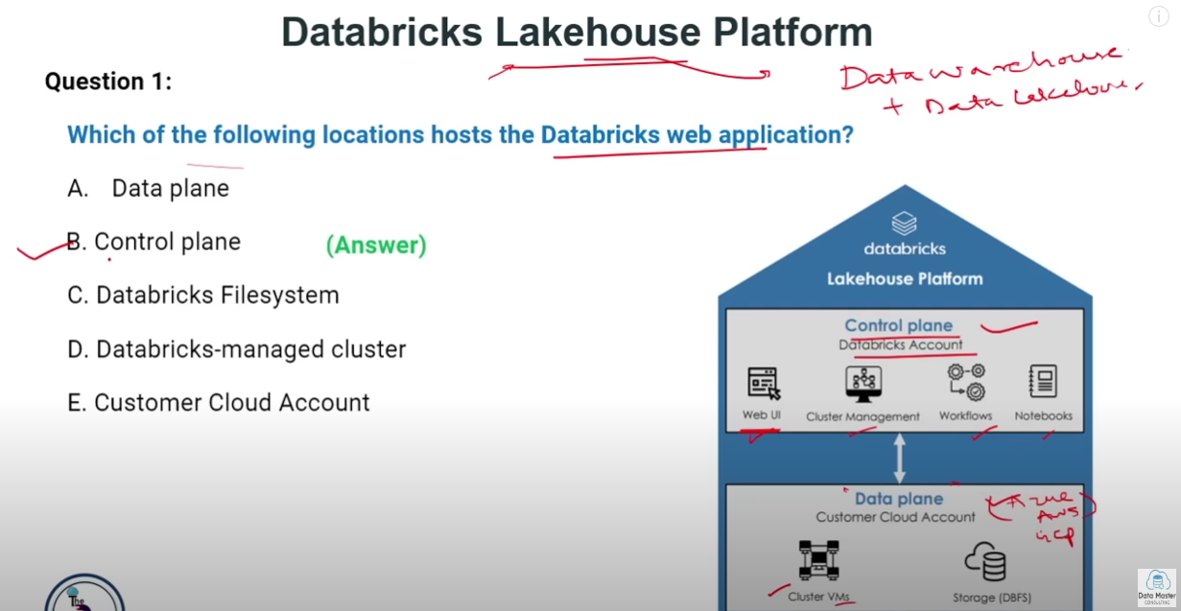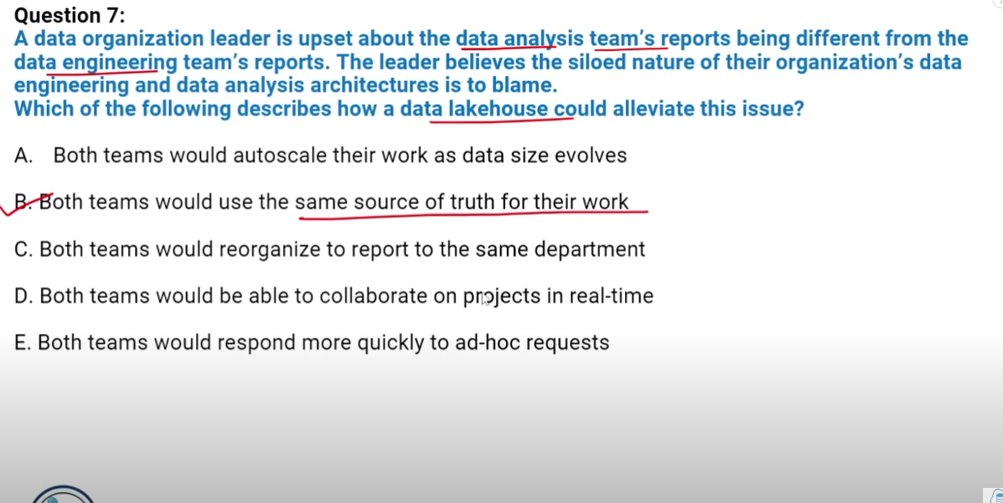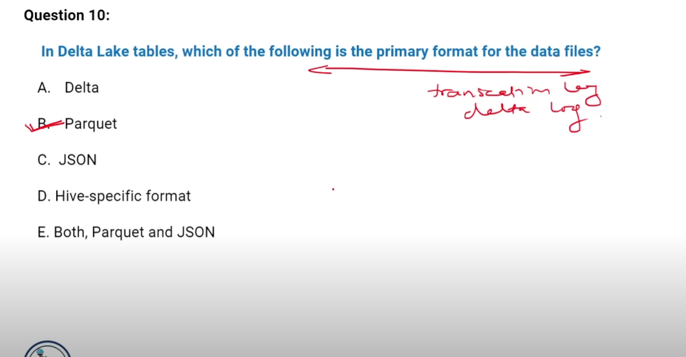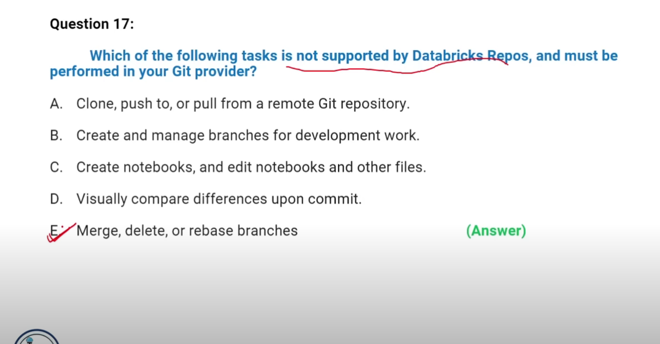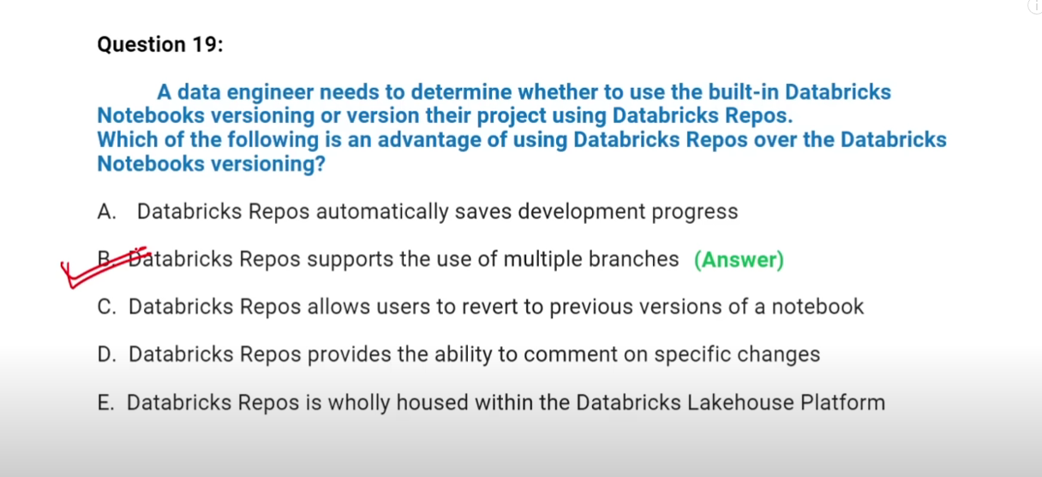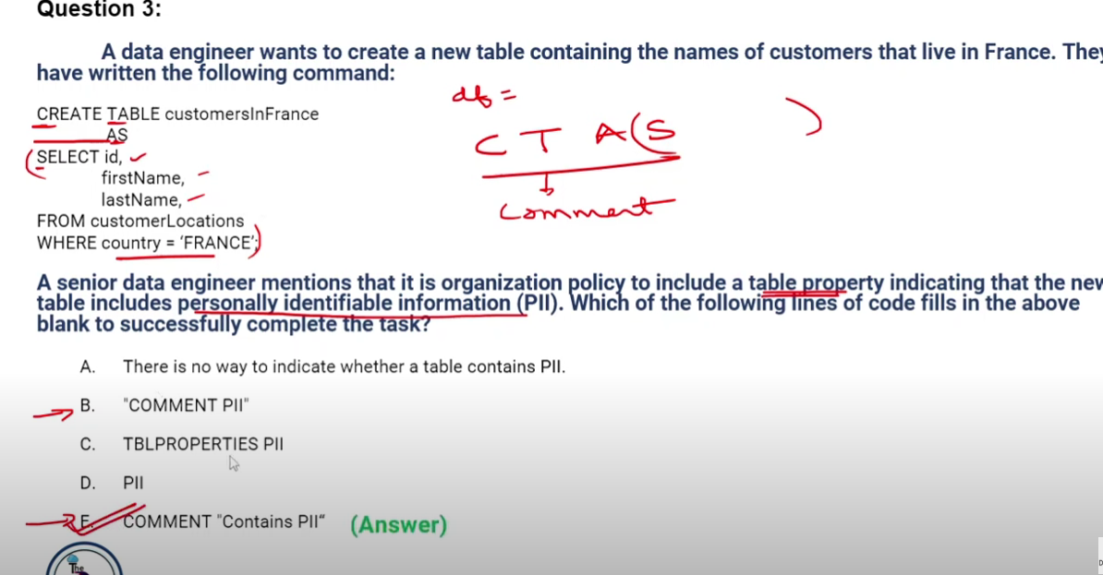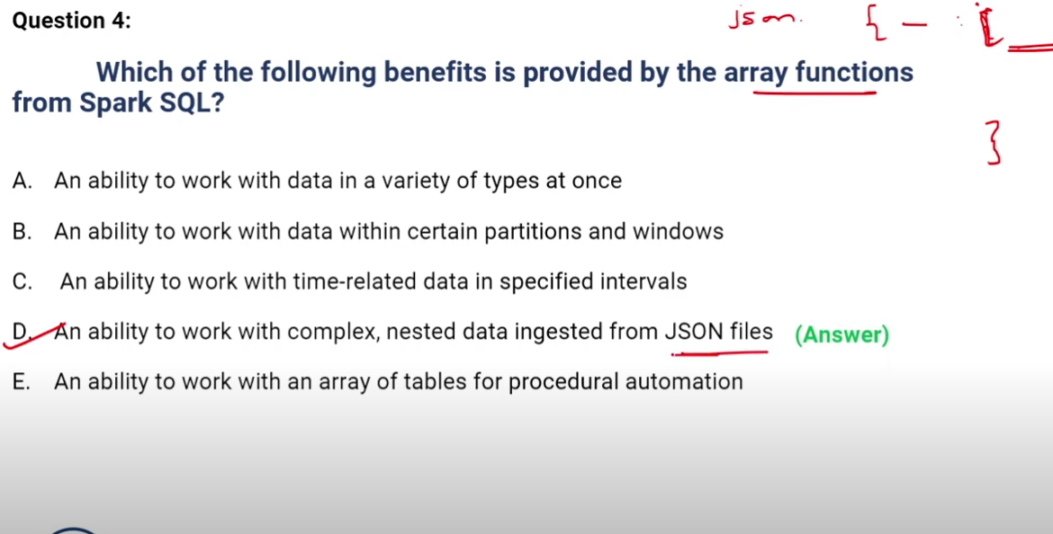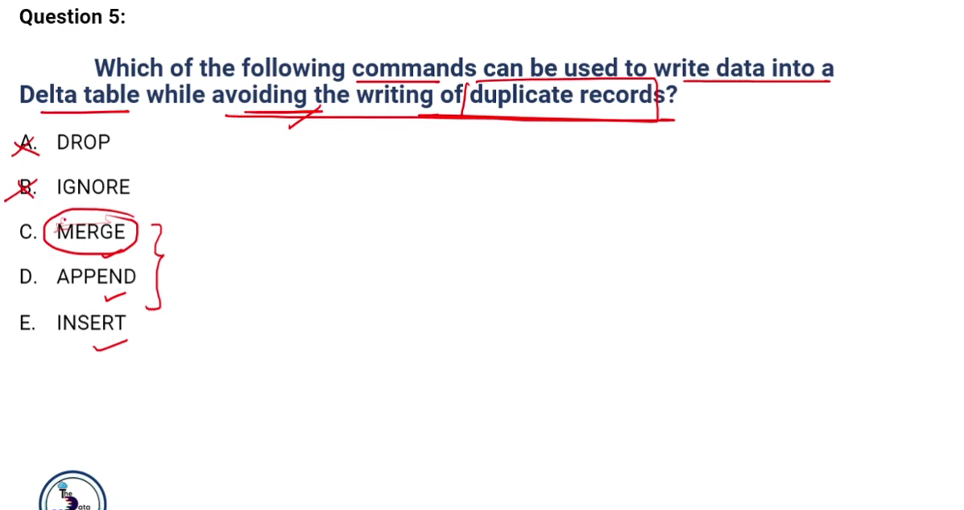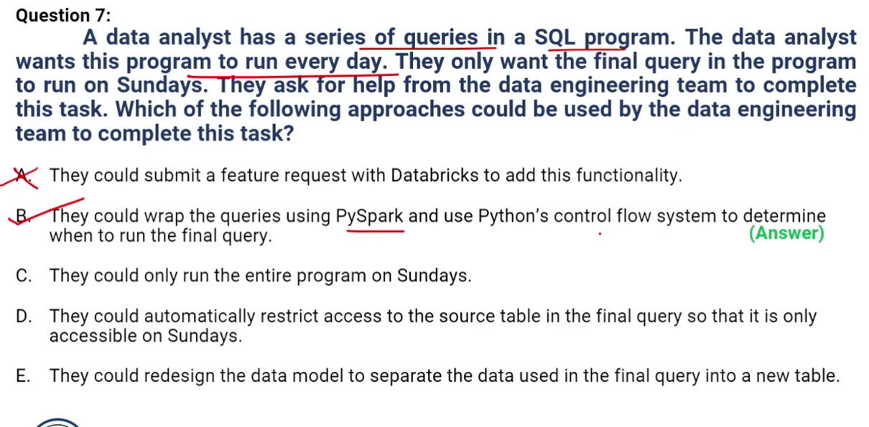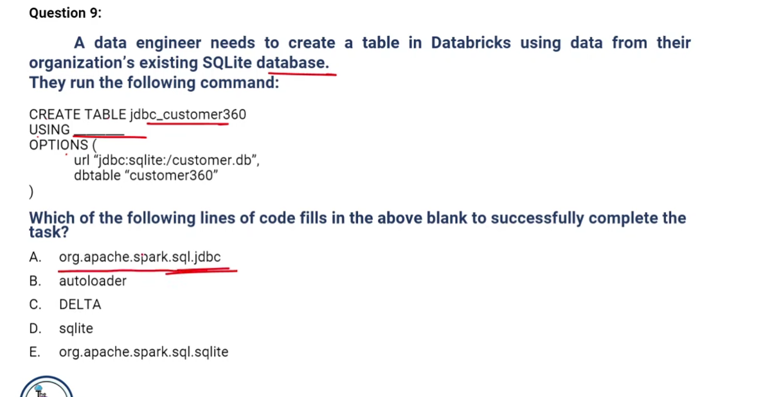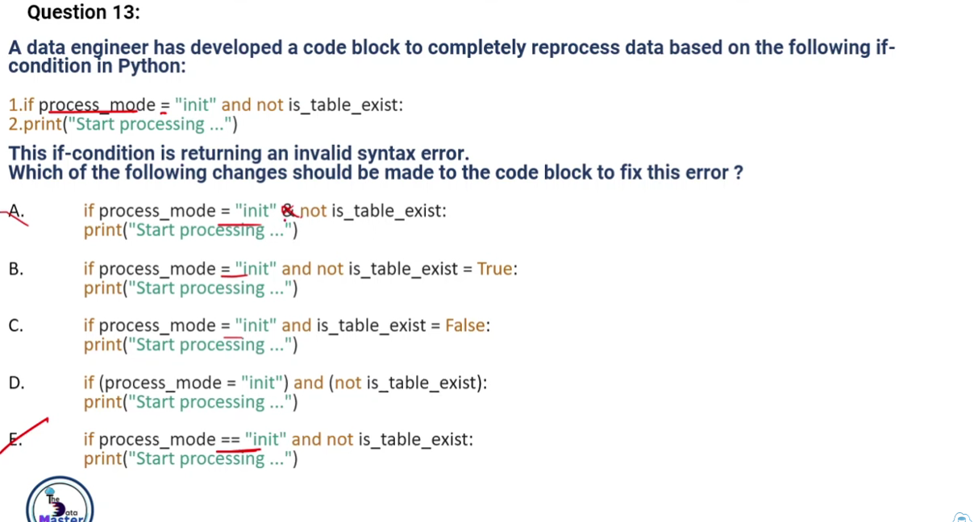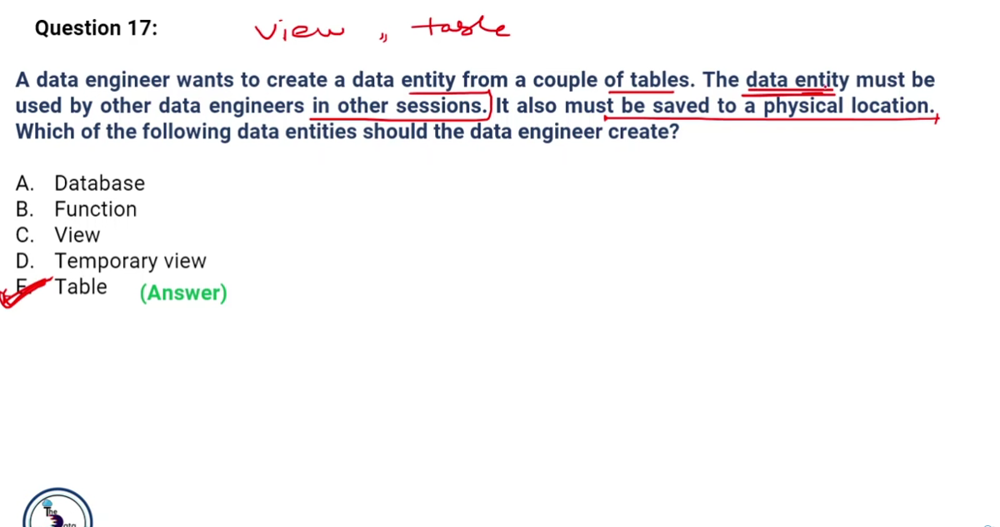

* Databricks Components: https://learn.microsoft.com/en-us/azure/databricks/getting-started/concepts
* Types of computes in data bricks: <https://learn.microsoft.com/en-us/azure/databricks/compute/>
* Debug the Notebooks: https://learn.microsoft.com/en-us/azure/databricks/notebooks/debugger

Cluster Pools in Databricks:

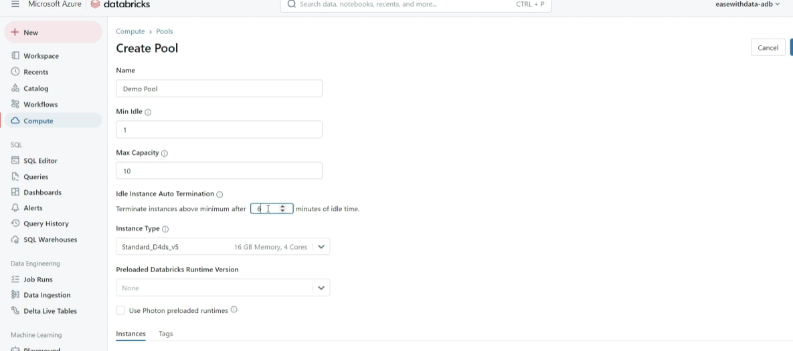

*In the above if the min idle is >0 then we call it a warm pool else the cool pool”. Once we are done with the pool creation, we can create a cluster (all-purpose/job compute) using this pool*

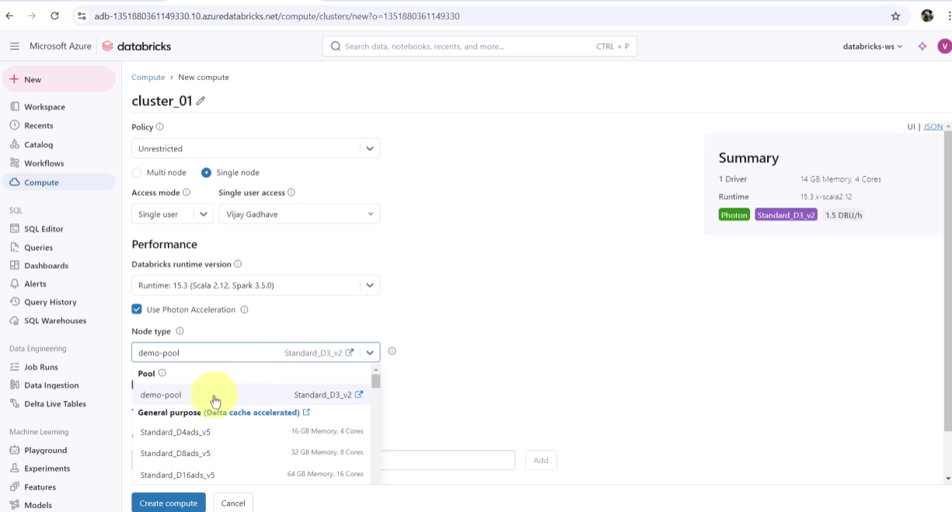

COPY INTO and Autoloader:

The COPY INTO SQL command lets you load data from a file location into a Delta table. This is a re-triable and idempotent operation; files in the source location that have already been loaded are skipped.

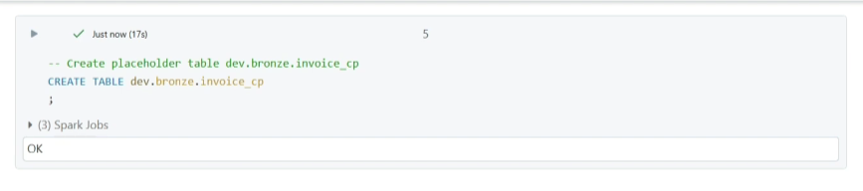

(Placeholder table or empty table)

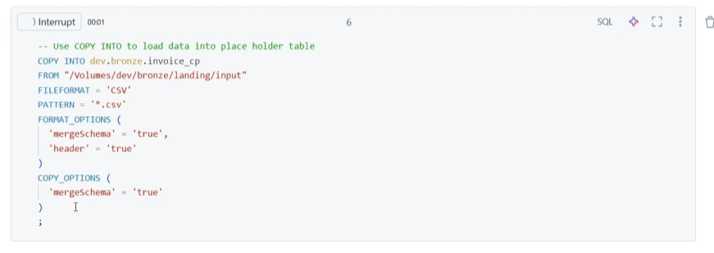

(syntax for COPY INTO)

Even if we rerun the above I will only fetch the new files. This is maintained in the metadata to keep track of what all data has been processed as shown below:

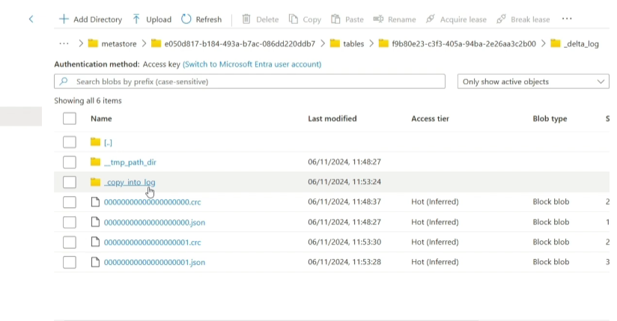

Auto Loader incrementally and efficiently processes new data files as they arrive in cloud storage. It provides a Structured Streaming source called cloudFiles. Given an input directory path on the cloud file storage, the cloudFiles source automatically processes new files as they arrive, with the option of also processing existing files in that directory.

File Detection Modes

* Directory Listing (uses API calls to detect new files) – default mode
* File notification (uses Notification and Queue services - requires elevated cloud permissions for setup)

*Autoloader identifies files and ensures that their metadata is saved in a scalable key value store (RocksDB) in its pipeline's checkpoint location.*

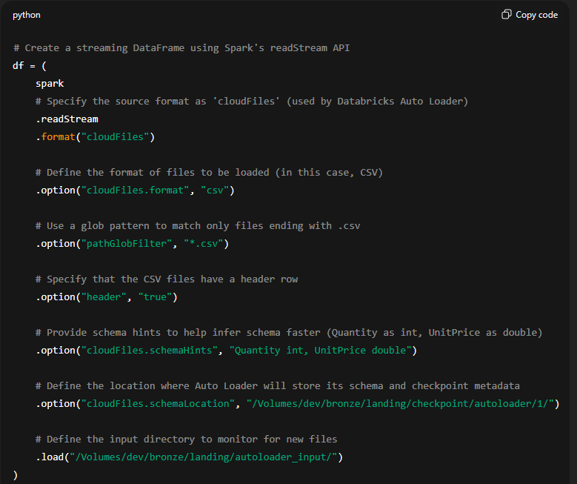

(Autoloader read stream)

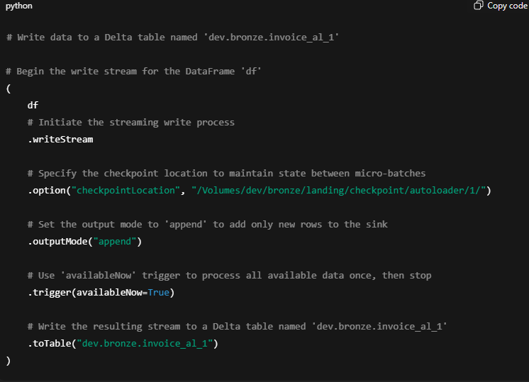

(Autoloader write stream)

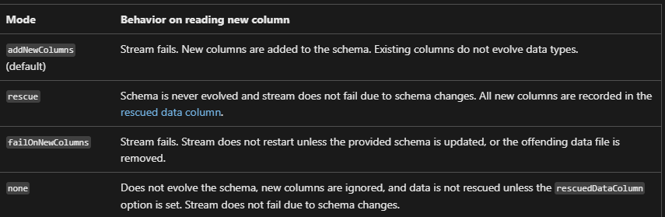

(different schema evolution modes supported by the autoloader)

* If we use the addNewColumns or the default mode then any changes in the schema of the data file will fail the write stream at first and this will also update the updated schema metadata in the checkpoint/schema path. When we run it again then it will work.
* In rescue, the stream will not fail rather a new col _rescue_data will get added in the schema that will store all the cols that were new to the incremental files and the same will get added in the target table.

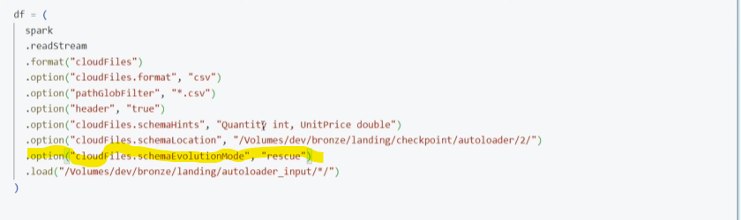

* If we use the none mode, any changes in the schema will be ignored and nothing will be rescued.

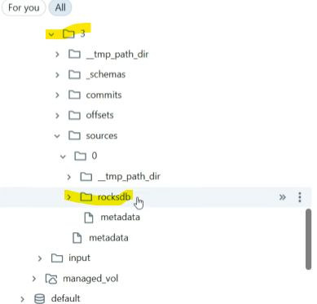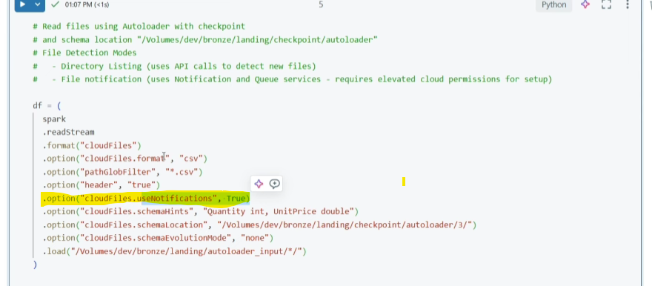

(to use the file notification mode)

Structured Streaming and the options

In streaming, data keeps coming in, and we want to decide *when* and *what* to write to the final destination (e.g., database, file, etc.).  
Output mode tells the system **which records to output during each processing cycle (trigger).**

| **Mode** | **What it does** | **When to use it** |
| --- | --- | --- |
| **Append** | Only outputs **new rows** that are **finalized** (won’t change anymore). | ✅ Best for notifications, logging, or events where each output should happen only once. |
| **Update** | Outputs **only changed rows** since last time — even if those rows might change again. | ✅ Best for dashboards or ML models that always need the **latest value**. |
| **Complete** | Outputs **everything** (all rows), every time. | ⚠️ Rarely used. Can be slow. Mostly for small datasets or full-table views. |

**⏰ Event Time**

The **time when the data event actually happened**, usually included as a timestamp in the data itself.

📌 Example: A user clicked a button at **2:35 PM**, and the event log has that timestamp.

**🕒 Processing Time**

The **time when Spark processes** the data — basically, when the data arrives at the engine.

📌 Example: The event from 2:35 PM arrives late and is processed by Spark at **2:45 PM**.

**🧠 Stateful Processing**

A type of processing where Spark **remembers information between batches** (triggers), like counts, averages, or sessions.

📌 Example: You’re counting clicks per user in a 1-hour window. Spark needs to **keep track of each user’s total** as new clicks come in.

| **Question** | **Bronze** | **Silver** | **Gold** |
| --- | --- | --- | --- |
| What happens in this layer? | Raw data ingestion | Data cleaning and validation | Dimensional modeling and aggregation |
| Who is the intended user? | * Data engineers * Data operations * Compliance and audit teams | * Data engineers * Data analysts (use the Silver layer for a more refined dataset that still retains detailed information necessary for in-depth analysis) * Data scientists (build models and perform advanced analytics) | * Business analysts and BI developers * Data scientists and machine learning (ML) engineers * Executives and decision makers * Operational teams |

ETL Using the Delta Live Tables:

Databricks Lake flow Declarative Pipelines are nothing but the DLT. This framework currently only supports SQL and Python.

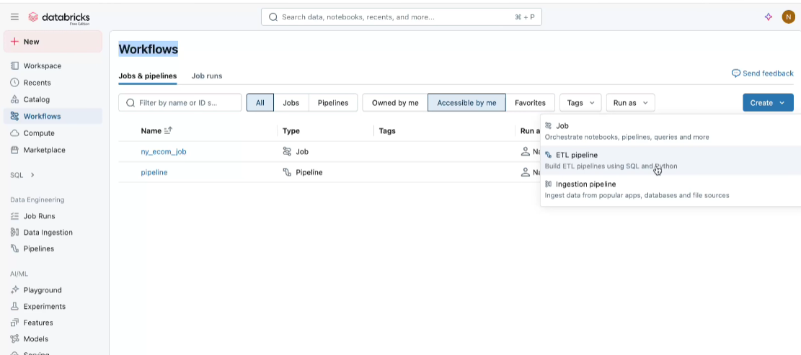

* Once we select the create ETL pipeline, you will be asked to select a work folder(for source code) that is dedicated to this specific pipeline.
* One thing to be noted here is that in the compute we have only serverless and job compute no option for all-purpose one.

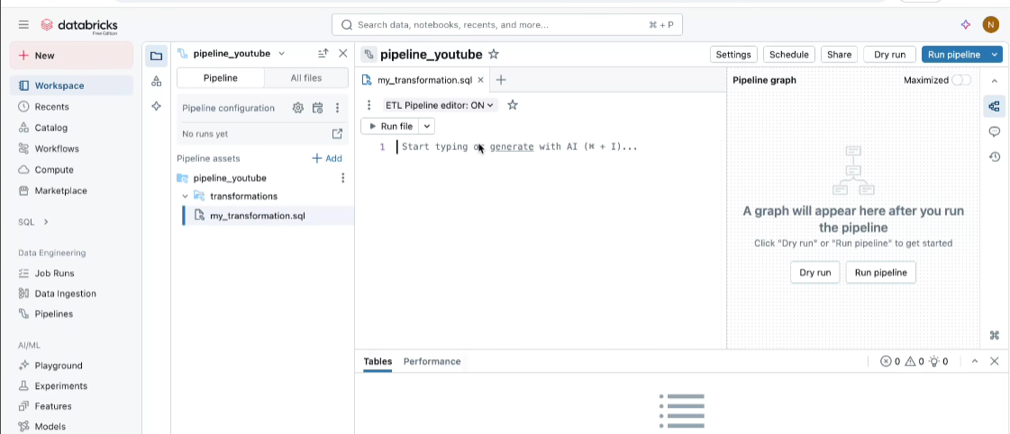

* Dry run will run the pipeline and check all tables, schema validation but will not create anything.
* As we add more SQL queries a pipeline graph will start getting created for the same pipeline.
* There are two DLT mode, Development and Production. So, when we use dev mode the compute (job) it keeps on running for 2 hrs approx. but in the case of prod mode as soon the pipeline finished the compute will stop immediately.
* Similarly, as above we two pipeline mode, trigger and continuous. trigger for batch whereas continuous for streaming.

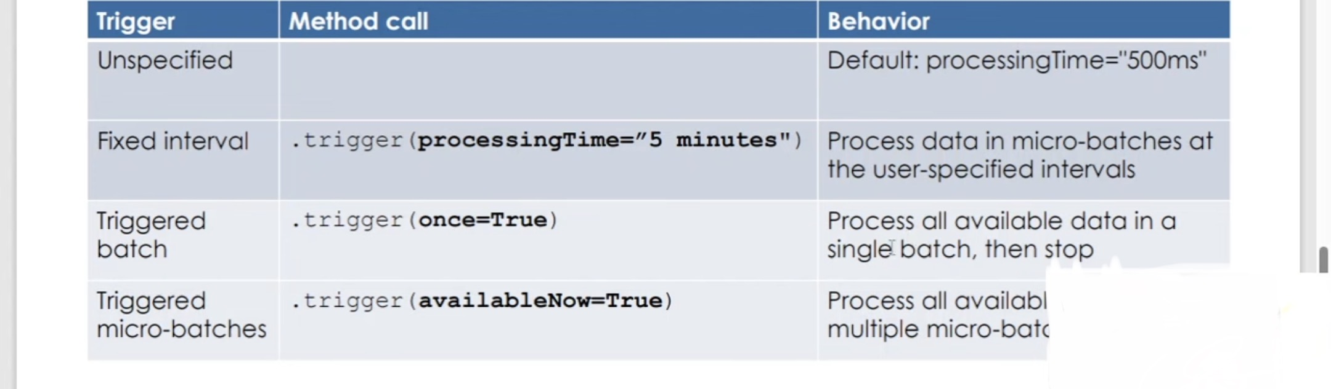

(diffrent trigger option in the write stream)

* A Delta Table is a data storage format.
* A Delta Live Table is a pipeline (with code + config) that creates and maintains Delta Tables.
* A Live Table is the output of a Delta Live Table pipeline — a table that:

You don’t create "Live Tables" directly; instead, they are automatically created and managed by your Delta Live Table (DLT) pipeline when you define tables using @dlt.table in Python or CREATE LIVE TABLE in SQL. Once the DLT pipeline runs, these tables appear as Live Tables in the Data tab and are backed by the Delta Lake format under the hood.

### **🔄 Auto Loader**

* A **feature of Structured Streaming**.
* Ingests new files **incrementally** from cloud storage (e.g., S3, ADLS).
* **Does not handle transformation or pipeline management**—only ingestion.

### **🔁 Delta Live Tables (DLT)**

* A **framework for building declarative data pipelines**.
* Supports **batch or streaming** modes.
* Handles **data ingestion, transformation, quality checks, and lineage**.
* Can **use Auto Loader under the hood** for source ingestion

Note: In DLT pipeline we can either create the table for a batch mode or a treaming mode here are the syntax for the same:

CREATE OR REFRESH LIVE my_batch_table

AS

SELECT *

FROM external_source_table;

CREATE OR REFRESH STREAMING LIVE my_streaming_table

AS

SELECT *

FROM STREAM(LIVE.source_table);

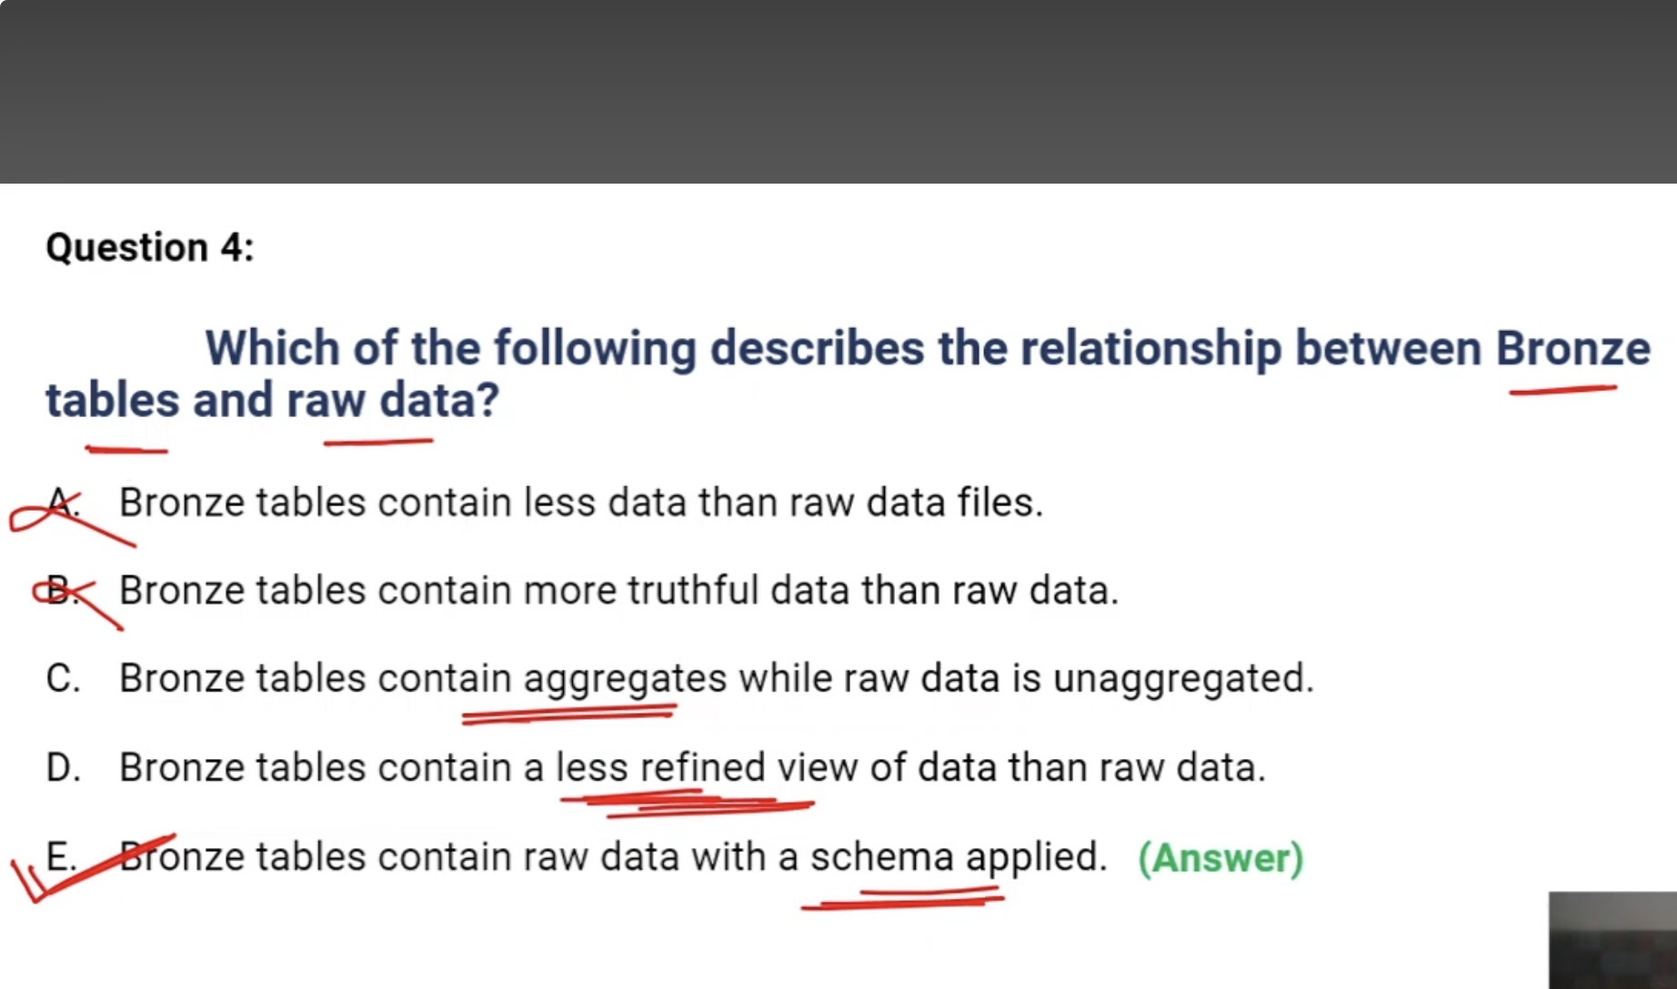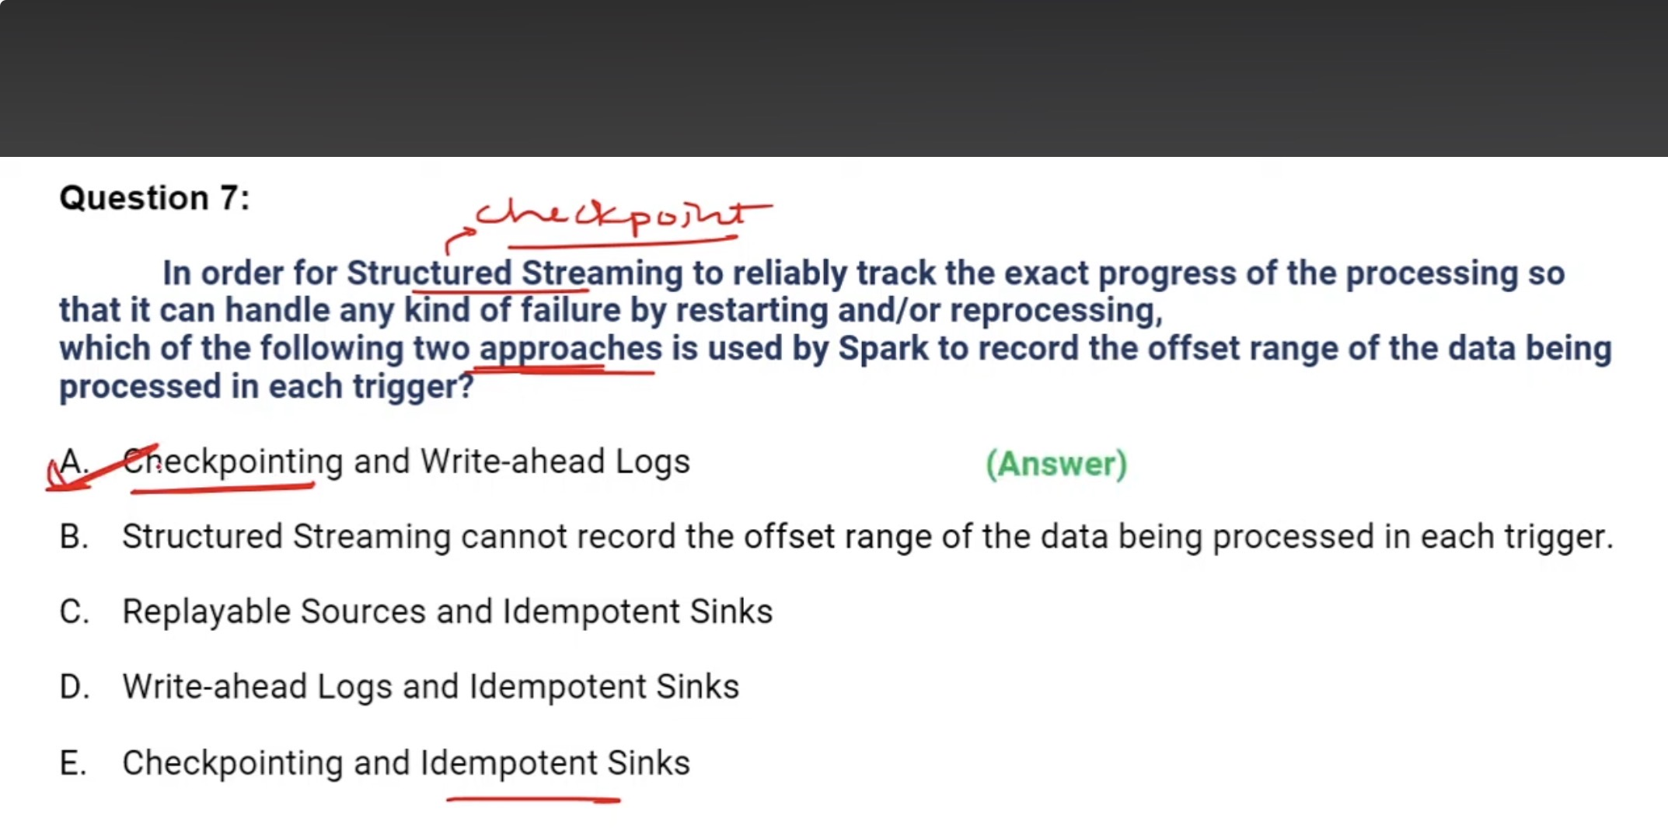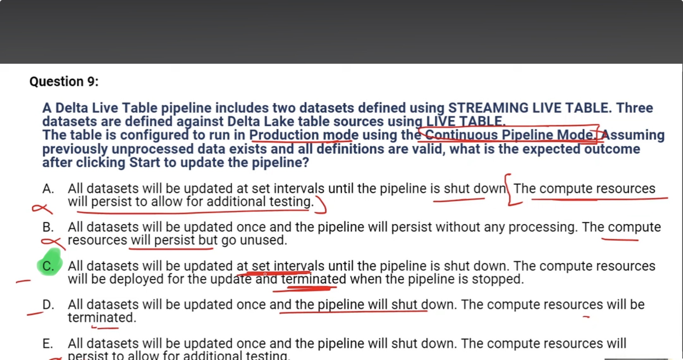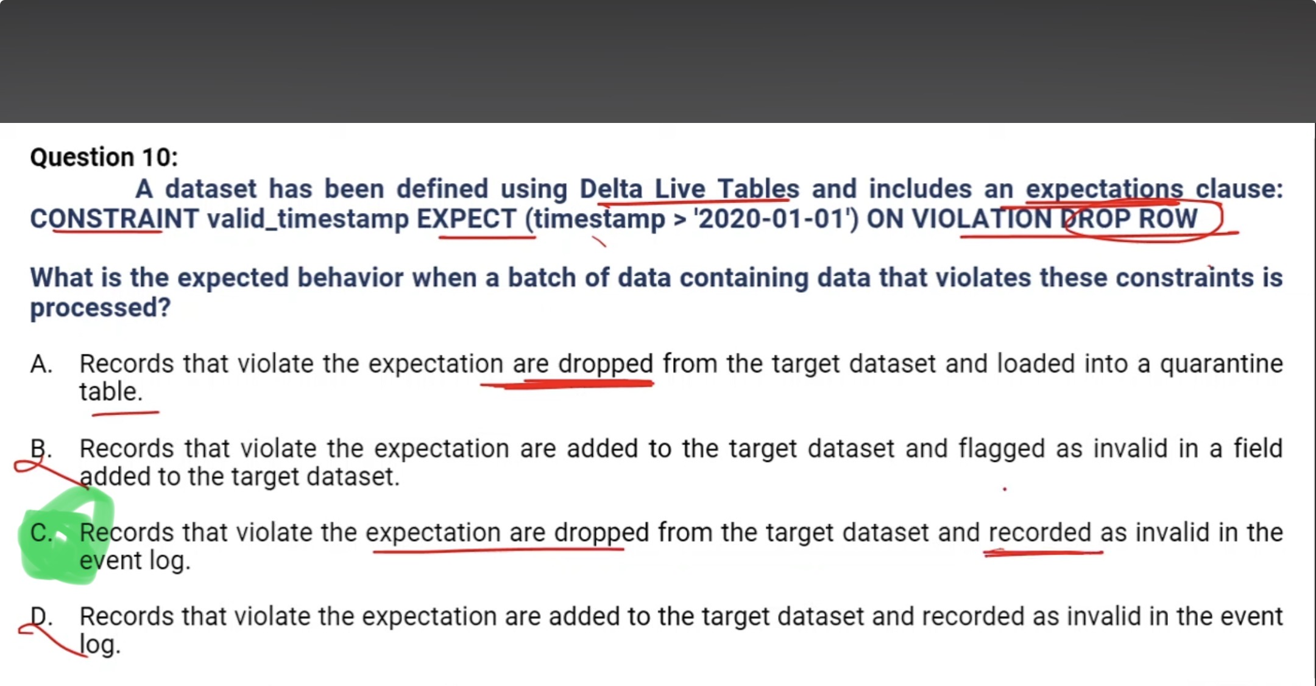

Use expectations to apply quality constraints that validate data as it flows through ETL pipelines. Expectations provide greater insight into data quality metrics and allow you to fail updates or drop records when detecting invalid records.

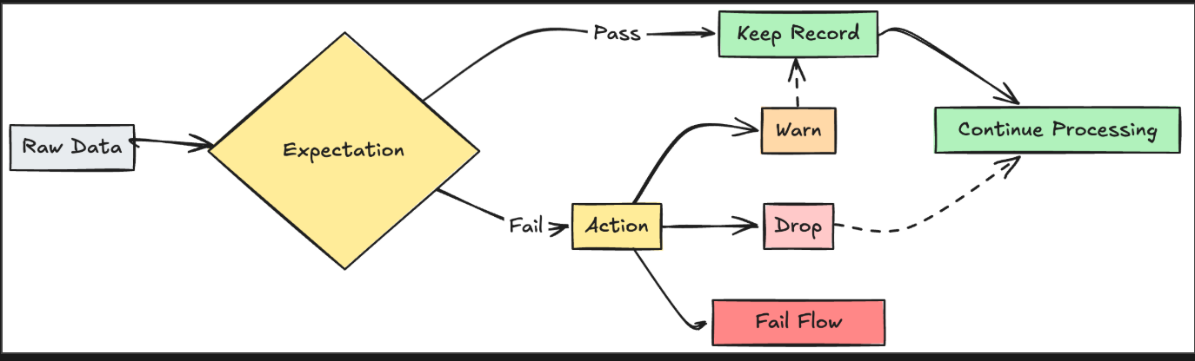

|  |  |  |  |
| --- | --- | --- | --- |
| **Action** | **SQL syntax** | **Python syntax** | **Result** |
| [warn](https://learn.microsoft.com/en-us/azure/databricks/dlt/expectations#retain) (default) | EXPECT | dlt.expect | Invalid records are written to the target. |
| [drop](https://learn.microsoft.com/en-us/azure/databricks/dlt/expectations#drop) | EXPECT ... ON VIOLATION DROP ROW | dlt.expect_or_drop | Invalid records are dropped before data is written to the target. The count of dropped records is logged alongside other dataset metrics. |
| [fail](https://learn.microsoft.com/en-us/azure/databricks/dlt/expectations#fail) | EXPECT ... ON VIOLATION FAIL UPDATE | dlt.expect_or_fail | Invalid records prevent the update from succeeding. Manual intervention is required before reprocessing. This expectation causes a failure of a single flow and does not cause other flows in your pipeline to fail. |

